Artificial Intelligence

# Lab Assignment 6

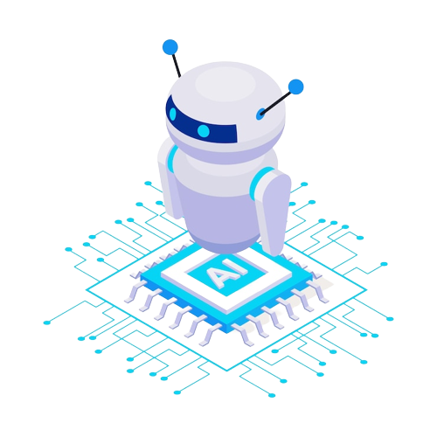

### Saad Bin Khalid 20K-0161

# Question 1

| 1  2  3  4  5  6  7  8  9  10  11  12  13  14  15  16  17  18  19  20  21  22  23  24  25  26  27  28  29  30  31  32  33  34  35  36  37  38  39  40  41  42  43  44  45  46  47  48  49  50  51  52  53  54  55  56  57  58  59  60 | // pins for motors  #define L_IN1 6  #define L_IN2 7  #define R_IN1 11  #define R_IN2 12  // pins for line sensors  #define L_SENS A0  #define R_SENS A1  // threshold value for sensors  #define THRESHOLD 500  void setup() {  pinMode(L_IN1, OUTPUT);  pinMode(L_IN2, OUTPUT);  pinMode(R_IN1, OUTPUT);  pinMode(R_IN2, OUTPUT);  }  void turnLeft() {  digitalWrite(L_IN1, LOW);  digitalWrite(L_IN2, HIGH);  digitalWrite(R_IN1, HIGH);  digitalWrite(R_IN2, LOW);  }  void turnRight() {  digitalWrite(L_IN1, HIGH);  digitalWrite(L_IN2, LOW);  digitalWrite(R_IN1, LOW);  digitalWrite(R_IN2, HIGH);  }  void stop() {  digitalWrite(L_IN1, LOW);  digitalWrite(L_IN2, LOW);  digitalWrite(R_IN1, LOW);  digitalWrite(R_IN2, LOW);  }  void forward() {  digitalWrite(L_IN1, HIGH);  digitalWrite(L_IN2, LOW);  digitalWrite(R_IN1, HIGH);  digitalWrite(R_IN2, LOW);  }  void loop() {  int L_val = analogRead(L_SENS);  int R_val = analogRead(R_SENS);  if (L_val > THRESHOLD && R_val > THRESHOLD)  forward();  else if (L_val > THRESHOLD)  turnLeft();  else if (R_val > THRESHOLD)  turnRight();  else  stop();  } |
| --- | --- |

# Question 2

| 1  2  3  4  5  6  7  8  9  10  11  12  13  14  15  16  17 | #define LED_PIN 9  void setup() {  pinMode(LED_PIN, OUTPUT);  }  void loop() {  for (int i = 0; i <= 255; i++) {  analogWrite(LED_PIN, i);  delay(10);  }    for (int i = 255; i >= 0; i--) {  analogWrite(LED_PIN, i);  delay(10);  }  } |
| --- | --- |

# Question 5

## Arduino VS Raspberry Pi

In the world of embedded systems and IoT, two well-known platforms are the Raspberry Pi and Arduino. They have many differences, however, they also share some similarities.

Raspberry Pi is a small, single-board computer that runs a full-fledged operating system (like Linux). It can run complex software applications because it has a strong processor (typically an ARM-based CPU) and enough RAM (typically 1GB or more). The Raspberry Pi is frequently used for tasks requiring connectivity and processing power, such as media centers, web servers, and robotics. Input/output (I/O) ports include HDMI, USB, Ethernet, and GPIO (General Purpose Input/Output) pins.

The Arduino, on the other hand, is a microcontroller board created for simple programming to control electronic devices. In contrast to Raspberry Pi, it has less memory and processing power, but it is extremely effective and has a wide range of interfaces for sensors and actuators. Arduino boards typically have digital and analog input/output pins, and they can be programmed using the Arduino Integrated Development Environment (IDE), which is a streamlined programming environment based on C/C. Robotics, automation, and sensor projects, which call for low-level control and real-time responsiveness, frequently make use of Arduino.

Both Raspberry Pi and Arduino have distinct roles to play in the world of artificial intelligence. Image recognition, natural language processing, and machine learning are just a few of the AI applications that can benefit from the computing power and connectivity of the Raspberry Pi. To control a robot or make decisions based on input, for instance, a Raspberry Pi-based project could analyze images taken by a camera using computer vision algorithms.

Meanwhile, Arduino's low-level control and real-time responsiveness make it a good fit for AI applications like robotics, automation, and sensors that call for precise control and quick responses. Machine learning algorithms, for instance, could be used in an Arduino-based project to identify patterns in sensor data (such as temperature, humidity, or vibration), and then use the information to modify a machine or device's behavior in real-time.

The smart garden system is an illustration of an AI project that combines Raspberry Pi and Arduino. In order to gather and analyze data from sensors and cameras (such as soil moisture sensors and temperature sensors), this project uses Raspberry Pi. Machine learning algorithms are then used to forecast plant growth and identify pests or diseases. The outcomes are then transmitted to an Arduino-based system, which uses the data to optimize plant growth and health by controlling actuators (such as water pumps, lights, and fans). In this project, Raspberry Pi and Arduino are used in tandem to build an intelligent system that combines data processing and control.

In conclusion, the Raspberry Pi and Arduino are two potent platforms that can be applied to a variety of AI applications. Raspberry Pi offers the connectivity and processing power required for data processing and analysis, whereas Arduino offers the low-level control and real-time responsiveness required for precise control and quick responses. Developers can build intelligent systems that take advantage of both the Raspberry Pi and Arduino's strengths by combining these two platforms.